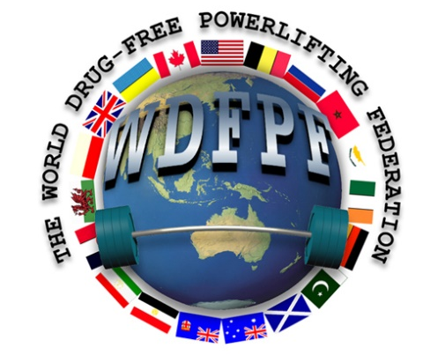
WORLD & EUROPEAN FULL POWER CHAMPIONSHIPS
LYNX FITNESS
2 WIMBLEDON AVENUE, BRANDON,
SUFFOLK, IP27 ONZ, ENGLAND
12-13 November 2022
Send to Your National Representative by 15/10/2022
Full Name
Nation
Date of Birth
Weight Class in Kgs |  | Age |  | Gender

Please indicate below the events you wish to enter
European championship
OR

xx
Euro EE
World championship

Saturday 12 November ALL men |  | Sunday 13th November ALL women
Full Power Equipped |  | Full Power Equipped
Full Power Unequipped |  | Full Power Unequipped

Cost of Entry: £65.00 – Note you can only enter either the Equipped or Unequipped NOT BOTH

Important Notice:
ALL PAYMENTS ARE TO BE MADE IN £ (GBP) ON THE DAY BY ATTENDING NATIONS. FAILURE TO ATTEND WILL RESULT IN 50% OF THE ENTRY FEE BEING PAID.

Weigh-in Times: 0700-0800 both days. From 0800 ONLY RE WEIGHS
Those arriving after this time will not be allowed to compete. I understand that I will automatically be entered in the OPEN CATEGORY along with an AGE-RELATED CATEGORY (teen/junior/master) if appropriate

RELEASE FROM LIABILITY
Please read this release very carefully, as when you sign it, you will be giving up important legal rights.
I hereby give my word of honour that I am life-time drug fee anabolic steroids or other anabolic agents that would be considered banned substances by the World Anti-Doping Agency (WADA)
In consideration of the acceptance of my entry form for this competition, I intend to be legally bound, for not only myself, but also my heirs, my executors and my administrators. In signing this release from liability, I waive and release anyone connected with this competition from any and all liability which may arise from this competition. Moreover, I agree that any testing method that WDFPF recognised testing officers may apply to detect the presence of drugs, as listed on World Anti-Doping Agency (WADA) banned substances list, SHALL BE CONCLUSIVE. I agree to co-operate fully with all required IOC sampling and testing procedures. This includes any testing procedures that may be considered necessary prior to or after this event. Should I fail to pass the drug testing procedures, I agree to forfeit any trophy, award, record or placing that I might otherwise have won and I also forfeit any previous trophy, award, record or placing, should the offence be deemed serious enough, according to WDFPF rules, to warrant such an action, I also agree to waive any claim which might arise under state, national or international law for defamation, slander, libel or any other claim for which legal relief is available. I agree to pay any attorney fees and litigation expenses incurred by any person, real or corporate, whom I may sue in effort to challenge this release from liability. I understand that my agreement to pay attorney fees and litigation expenses is the SINE QUA NON for acceptance of my entry in this contest.

I ADDITIONALLY AGREE FOR: Results of the event & drug tests to be published on the WDFPF/affiliates websites.

Signature:
Date:
THIS ENTRY FORM IS FOR WDFPF AFFILATE MEMBERS ONLY

